Contents

1 Nutanix Login Details 1

2 Nutanix Dashboard Details 1

3 Detailed Nutanix Health Check 3

4 vCenter Login Details 6

5 vCenter Monitoring 6

6 Escalation Matrix 6

# 1 Nutanix Login Details

Login to Nutanix Prism Element (IOCC AD account **E_ADM_IOCC_WIN_SERV** configured as read only access)

Currently we have following Nutanix cluster in our environment details as follows

|  |  |  |
| --- | --- | --- |
| **Nutainix Cluster Name** | **FQDN for Prism Element** | **IP of Prism Element** |
| IAD-W-PRD-VDI-01-NX | IAD-W-PRD-VDI-01-NX.healthspring.inside | 10.118.33.100 |
| EWR-W-PRD-VDI-01-NX | EWR-W-PRD-VDI-01-NX.healthspring.inside | 10.116.33.100 |
| IAD-W-PRD-VDI-02-NX | IAD-W-PRD-VDI-02-NX.healthspring.inside | 10.118.33.105 |
| EWR-W-PRD-VDI-02-NX | EWR-W-PRD-VDI-02-NX.healthspring.inside | 10.116.33.105 |

# 2 Nutanix Dashboard Details

Once you login Prism Element you will get Dashboard page which will give you almost all cluster health details.

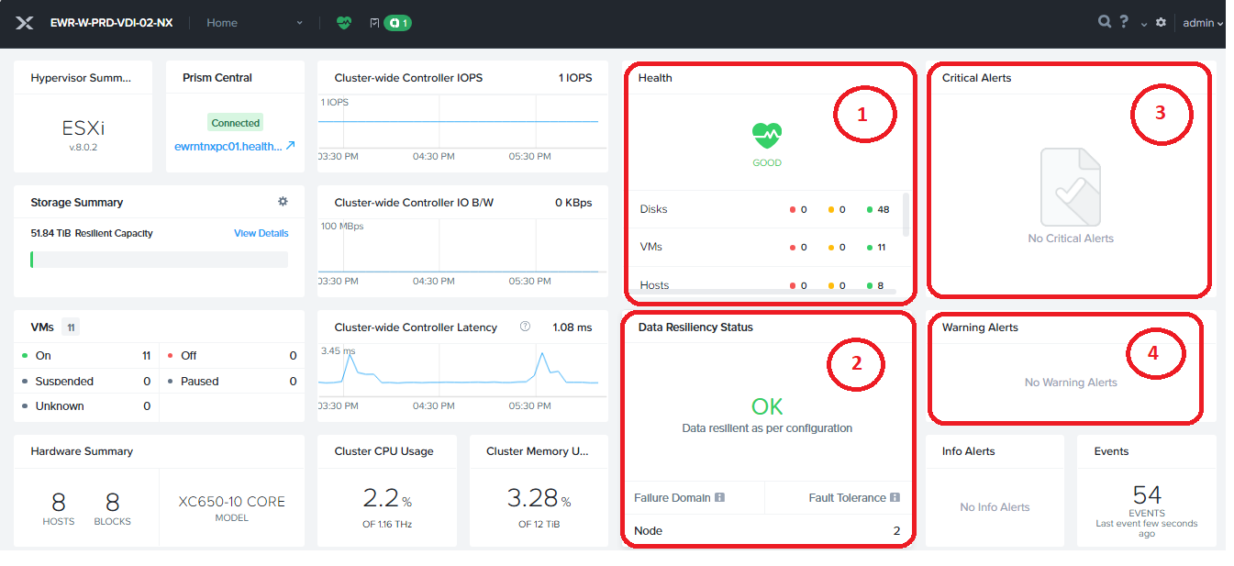

In above dashboard we have to monitor 4 widgets which is most important details explanation of this widget as follow.

1. **Health Widget**: displays health status for the cluster as a whole (good, warning, critical) and summary health status for the VMs, hosts, and disks in the cluster. **If it is anything other than Good status, please contact to Nutanix Team (tcswintelteam@evernorth.com).**
2. **Resiliency Status**. Indicates whether the cluster can safely handle a node failure, that is whether a copy exists somewhere in the cluster of all data in any node. If the status is not OK, the Data Resiliency Status window includes a message about the problem. **If status is not OK and Fault Tolerance is below than 2 then please contact to Nutanix Team (tcswintelteam@evernorth.com)**
3. **Critical Alerts Widget:** Displays the most recent unresolved critical alert messages. Click a message to open the Alert screen at that message. **If there is any critical alert on this section, then please contact to Nutanix Team (tcswintelteam@evernorth.com)**
4. **Warning Alerts Widget:** Displays the most recent unresolved warning alert messages. Click a message to open the Alert screen at that message. **If there is any warning alert on this section, then please contact to Nutanix Team (tcswintelteam@evernorth.com)**

# 3 Detailed Nutanix Health Check

To check detailed health status of cluster follow below procedure.

1. Login to Prism Element
2. Go to health page by clicking on **Home** button on top toolbar after that click on Health option.

1. Once Health page open you can check on left side pane number of wanning and critical errors on the cluster. Usually there should be 0 failed, warning and errors available as below**. If any error, warning or failed entity shows contact to Nutanix team (tcswintelteam@evernorth.com).**

1. To check latest health status Initiate new health check, Click **Action** on right hand side thenclick on **Run NCC Check.**

1. Then new window popups select **All Checks** and then Click on **Run.**

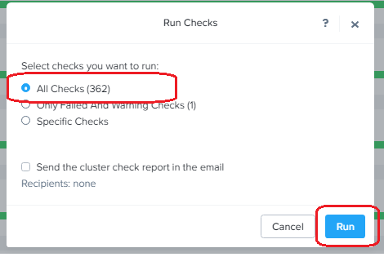

1. Once you start health check you can check status on Task toolbar. Click on 

1. Once Task is finished successfully as follows.

1. Check again health report in Health page as explained in step **b and c**

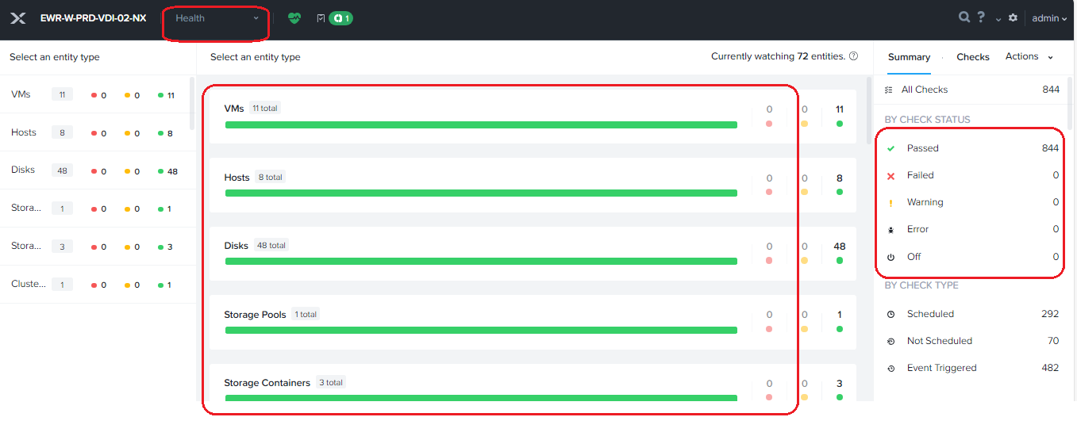

# 4. Nutanix Alerts Priority

Please find below excel for details of errors and their priorities.

[Nutanix Alerts Category.xlsx](https://cignatlp.sharepoint.com/:x:/r/sites/GovernmentDivestitureMigration/Shared%20Documents/Datacenter/Runbook%20and%20OPS/Compute/Nutanix/Nutanix%20Alerts%20Category.xlsx?d=w9b88941d44ec4053974a552c4cb022d0&csf=1&web=1&e=5nNdvf)

# 5 vCenter Login Details

Here in Nutanix we are using Esxi as a hypervisor which managed by vCenters. Details of vCenter as follows. (IOCC AD account **E_ADM_IOCC_WIN_SERV** configured as read only aceess)

|  |  |  |  |
| --- | --- | --- | --- |
| **Nutanix Cluster Name** | **vSphere Cluster Name** | **FQDN for vCenter** | **IP for vCenter** |
| IAD-W-PRD-VDI-01-NX | IAD-W-PRD-CITRIXVDI-01-D | iadvcsmp02.healthspring.inside | 10.118.4.72 |
| EWR-W-PRD-VDI-01-NX | EWR-W-PRD-CITRIXVDI-01-D | ewrvcsmp02.healthspring.inside | 10.116.4.92 |
| IAD-W-PRD-VDI-02-NX | IAD-W-PRD-CITRIXVDI-02-D | iadvcsmp02.healthspring.inside | 10.118.4.72 |
| EWR-W-PRD-VDI-02-NX | EWR-W-PRD-CITRIXVDI-02-D | ewrvcsmp02.healthspring.inside | 10.116.4.92 |

# 6 vCenter Monitoring

We already have separate document for vCenter monitoring you can follow same for monitoring purpose; Document link as follows.

[IAD (Project Silverton) vCenter Monitoring SOP for IOCC Team.docx](https://cignatlp.sharepoint.com/:w:/r/sites/GovernmentDivestitureMigration/Shared%20Documents/Datacenter/Runbook%20and%20OPS/Compute/Vmware/IAD%20(Project%20Silverton)%20vCenter%20Monitoring%20SOP%20for%20IOCC%20Team.docx?d=w9b3a9482e0074567bd0a628a840920f7&csf=1&web=1&e=I2LrDl)

# 7 Escalation Matrix

Please find below excel of escalation matrix for VMware and Nutanix issues.

[Escalation Matrix.xlsx](https://cignatlp.sharepoint.com/:x:/r/sites/GovernmentDivestitureMigration/Shared%20Documents/Datacenter/Runbook%20and%20OPS/Compute/Nutanix/Escalation%20Matrix.xlsx?d=w8ef2a299568145a8bd20655d7e5e3352&csf=1&web=1&e=22mGEw)